Lab 4 plus
*Lab 4 plus is a combination of Lab 4 and an extra activity on ARP.

Packet Tracer Simulation – Exploration of ARP and Switch Table Communications

Objectives
- To explore ARP and switching operations.
Introduction
The topology is given to you. All IP addresses have been assigned to all devices. Please follow each step in sequence.
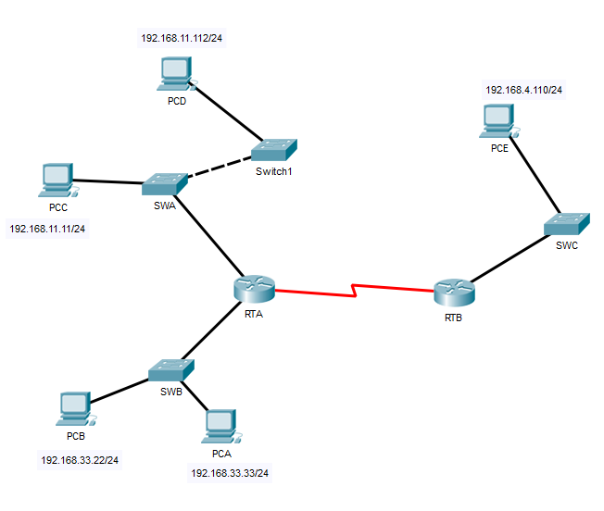
Figure 1

Part 1: Review the topology

Step 1: Perform the following tasks.
- At Router RTA, enter the CLI. At the command prompt type the following commands. Snap the results after the last command and paste it here.
RTA>enable

RTA#show arp

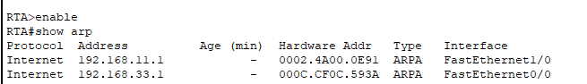
- At Router RTB, enter the CLI. At the command prompt type the commands as in Figure 2. Snap the results after the last command and paste it here.

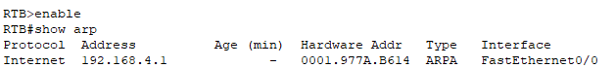

- At Switches SWA, SWAB and SWC, enter the CLI. At the command prompt type the following commands. Snap the results after the last command and paste it here.
SWA>enable

SWA#show arp

SWA#show mac-address-table

Switch SWA
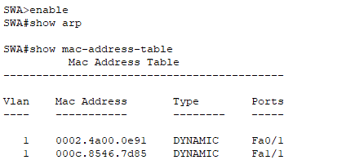

Switch SWB

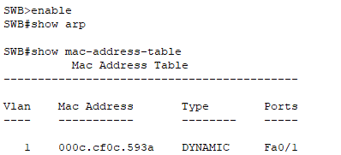

Switch SWC

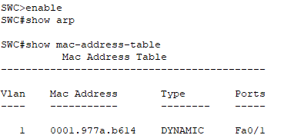

- At PCA, click on the PC icon, and then choose Desktop-Command Prompt. At the command prompt type arp –a and click enter. Snap the results after the last command and paste it here. Do this to all PCs in the topology.

PCA

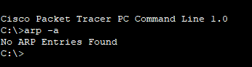

PCB

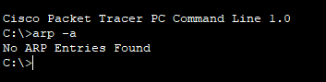

PCC

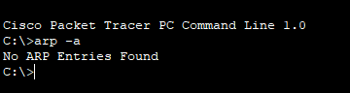

PCD

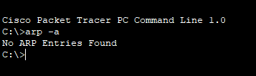

PCE

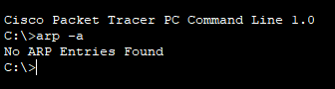
- What are your thoughts on the results?

No entry for all PCs because all the PCs didn’t receive any ARP request.

There will be no entry in the PC ARP table.

Part 2: Generate Network Traffic

Step 1: Generate traffic between PCA and PCB.
In the command prompt Perform the following tasks task to reduce the amount of network traffic viewed in the simulation.
- Click PCA and click the Desktop tab > Command Prompt.
- Enter the ping 192.168.33.22 command. This may take a few seconds.
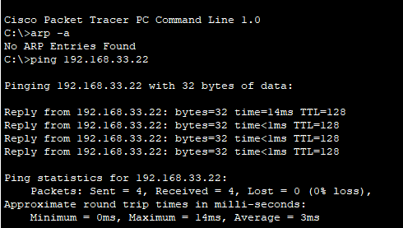

- In the Command prompt of PCA, type arp –a. Paste the result of this command here.
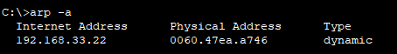
- In the Command prompt of PCB, type arp –a. Paste the result of this command here
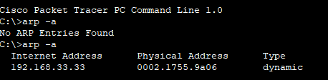
- In the Command prompt of PCC, PCD abd PCE, type arp –a. Paste the result of this command here.
PCC
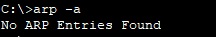
PCD
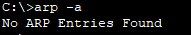
PCE
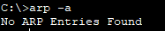

Step 2: Generate traffic between PCC to all other PC except PCA.
- Click PCC and click the Desktop tab > Command Prompt.
- Enter the ping 192.168.33.22 command (ping to PCB). Then type arp –a. Paste the result after these commands here.
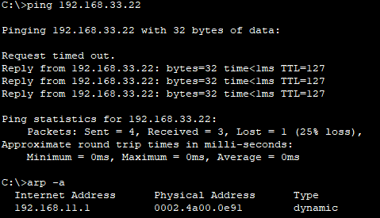

- Enter the ping 192.168.11.112 command (ping to PCD). Then type arp –a. Paste the result after these commands here.
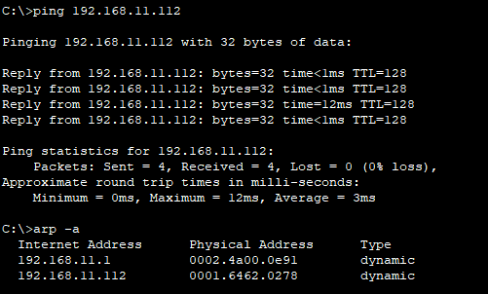
- Enter the ping 192.168.4.110 command (ping to PCE). Then type arp –a. Paste the result after these commands here.
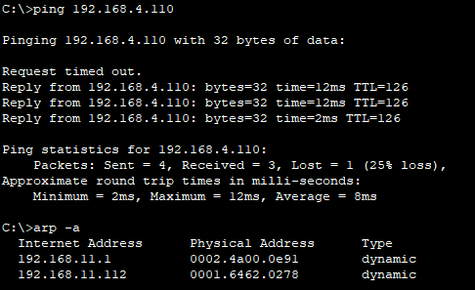
- Discuss the results you got from all the commands on PCC.
The ARP entries are revealed in the ARP table only after PCC pings PCB,
PCD, and PCE. No ARP entries are found before these ping activities. The
ARP table displays entries once PCB, PCD, and PCE receive the ARP request
from PCC and subsequently receive pings from PCB, PCD, and PCE.

- At Router RTA, enter the CLI. At the command prompt type the following commands. Snap the results after the last command and paste it here.
RTA>enable

RTA#show arp

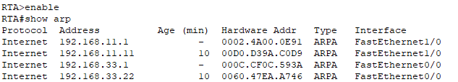
- At Router RTA, enter the CLI. At the command prompt type the following commands. Snap the results after the last command and paste it here.
RTB>enable

RTB#show arp

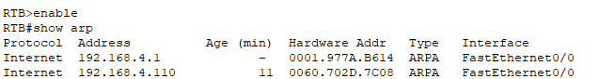

Step 3: Switch MAC address table.
- At Switch SWA, enter the CLI. At the command prompt type the following commands. Snap the results after the last command and paste it here.
SWA>enable

SWA#show arp

SWA#show mac-address-table
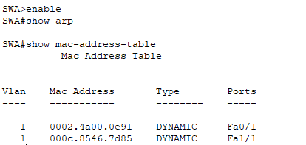
- At Switch SWB, enter the CLI. At the command prompt type the following commands. Snap the results after the last command and paste it here.
SWB>enable

SWB#show arp

SWB#show mac-address-table

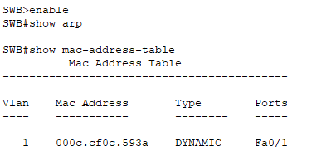

- At Switches SWC and Switch1, enter the CLI. At the command prompt type the following commands. Snap the results after the last command and paste it here.
SWC>enable

SWC#show arp

SWC#show mac-address-table

Switch SWC
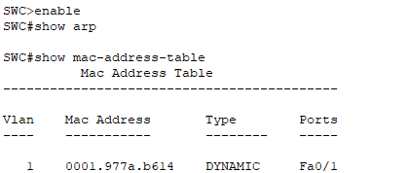

Switch 1
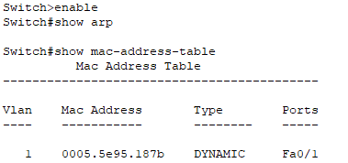
- Do switches use arp table? (Y/N)
Yes
- Explain your answer in (d) *Hint: the answer may surprise you. Google for the explanation. It is not part of NetComm syllabi, it is just for knowledge..
Switches utilize an ARP table to store the IP addresses and corresponding
MAC addresses of network devices. This table serves the purpose of
identifying the destination MAC addresses for communication with network
nodes.
- What information does the command show mac-address-table gives?
To view MAC address table entries on a switch, the term "DYNAMIC"
specifically pertains to displaying MAC addresses that have been learned by
the switch during its operation.

Part 3: Attach wireless lab results.
In this part, you will use Lab 4 .pka file.
Step1: Change the filename of Lab 4.
- Change the Lab 4 filename to include your name. *Example: Lab4AliAhmad.pkt
- Go through the instructions. As you complete the tasks, you will see the bottom right hand corner of the pkt file increase in completion percentage, until you get 100/100.

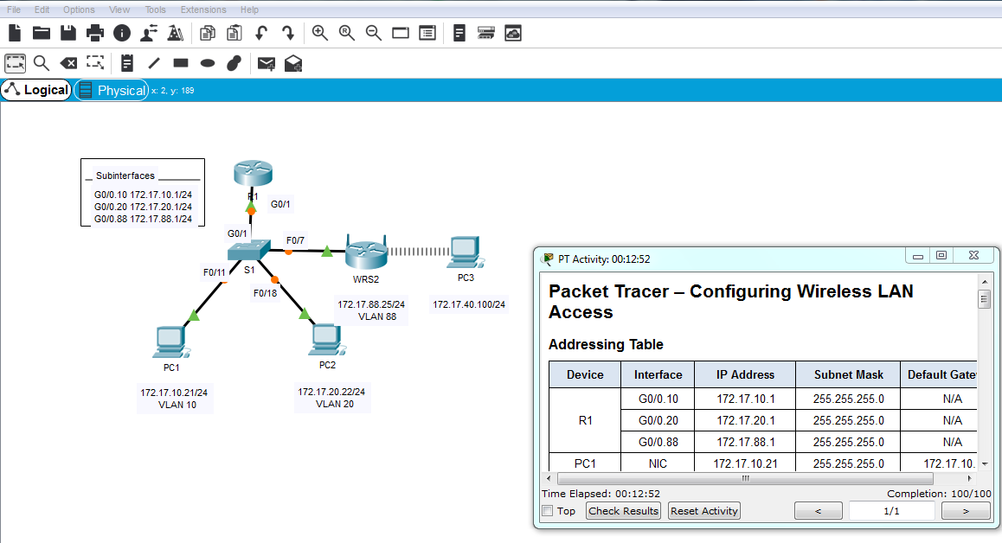
- Once you have completed fully, capture the screen (which includes the filename, the topology and the activity wizard showing completion) and paste it here.
